Smart Farming and Agriculture Management app
Contents
1. Abstract 2
2. Elicitation Techniques 3
2.1. First Technique: Reading existing documents (Background reading) 3
2.2. Second Technique: Focused Group meeting (Brainstorming) 3
2.3. Third Technique: Client Interview 3
3. Functional and Non-Functional Requirements 3
3.1. Functional Requirements 3
3.2. Non-Functional Requirements 3
4. Models 4
4.1. UML Use Case diagram 4
4.2. UML Sequence diagrams 4
4.3. UML Activity diagrams 4
4.4. UML State diagrams 4
Appendix A: Elicitation techniques 5
Background Reading 5
Group Brainstorming 6
Client Meeting 7
Appendix B: Work Breakdown Structure 8
Appendix C: Functional Requirements 9
Farmer 9
Government Authorities 9
Academic institutions 9
Additional assumptions 9
Appendix D: Non-Functional Requirements 10
Performance 10
Reliability 10
Usability 10
Security 10
Interoperability 10
Localisation 10
Appendix E: UML Diagrams 11
Use Case UML Diagram 11
Sequence UML Diagrams 12
Enter Data 12
View Data 12
Log Data 13
Request Recommendations 13
Get Report 14
View Limited Data - Government 14
View Limited Data - Academics 15
Activity UML Diagram 16
Customise Homepage 16
Log Data 17
Request Report 18
Request Recommendation 19
Enter Data 20
View Limited Data 20
View Limited Soil Data 21
View Limited Plant Data 21
View Data 22
State UML Diagram: 23
Farming System State Diagram 23
Database State Diagram 23
Appendix F: Agile and Scrum Planning 24

Abstract
This report includes the methods we used to complete our assignment, including the choices of Elicitation Techniques (Refer to Appendix A), such as background reading followed by brainstorming sessions and client interviews to refine the project’s requirements and establish an Agile and Scrum planning framework. We created a Work Breakdown Structure (WBS) (Refer to Appendix B) and defined functional and non-functional requirements (Refer to Appendix C and D). This comprehensive approach ensures we get everything done step by step without messing up the tasks and rules of each group member.

After getting the Agile and Scrum planning done (Refer to Appendix F). It was time to allocate individual responsibilities based on the specific tasks required to complete the assignment, as well as assigning sprints for each one. This allowed us to establish a clear timeline of the project and ensure that every team member had a well-defined role. Furthermore, we organised online discord meetings to keep everyone on track and address any potential problems as soon as possible to be discussed and fixed.

Elicitation Techniques

First Technique: Reading existing documents (Background reading)
As a start, it was essential for each group member to have an understanding of their own about the problem statement. As a group, we committed to conducting independent research on the chosen problem statement and the approach to comprehensively understand it (Refer to Appendix A section 1).
Our choice to use this elicitation technique was due to the fact that we had five members in our group, this gave us more flexibility and diversity of opinions and points of views about the problem statements and things it includes.

Second Technique: Focused Group meeting (Brainstorming)
In a second meeting, we engaged in a brainstorming session to further refine our understanding of the requirements of the problem statement, in addition to gathering our findings during our background reading project plan. Then we prepared questions for the meeting with the client (Refer to Appendix A section 2). This method was ideal for us due to the number of people in our group, this allowed us to have five minds collaborate to understand the requirements.

Third Technique: Client Interview
As a last elicitation technique, we had an interview with the client to have questions answered as well as to clear any doubts we still had after the previous two techniques. (Refer to Appendix A section 3). This helped us to clarify that our understanding of the requirements was not out of scope. The choice of having a face-to-face interview with the client was ideal as it helped us understand the project from their point of view and how they wanted the app to function.

Functional and Non-Functional Requirements

Functional Requirements
After we had a clear scope of our project, it was time to specify the functionality of the application, starting with the Functional Requirements. After getting a draft, we reviewed all of the functional requirements, discussed changes to be made such as adding descriptions of each one and the ability of using each one as a user story to differentiate between it and Non-Functional Requirements, and applied some changes at the end that everyone agreed with (Refer to Appendix C). In addition, these requirements will assist us with the making of UML Use case diagrams and UML Sequence Diagrams as both diagrams visualise the functionality of the proposed system.

Non-Functional Requirements
For the Non-Functional Requirements, we had to change our direction of thoughts and start identifying the characteristics of the application relating to usability, performance, reliability, security, interoperability and localisation (Refer to Appendix D). All of these characteristics will help in the process of creating the models such as UML activity diagrams, and UML state diagrams later as both models visualise the dynamic behaviour of relevant objects in the application domain of the proposed system. This as well helps us know the specifications that describe the system’s operating capabilities. We tried to keep things as simple as we can and not include very complicated requirements to keep it more modular (Refer to Appendix D).

Models
Before getting started with any diagram we first had to state the actors and functions (Actions) that our system can do, such as log data, enter data, get recommendations, etc. (Refer to Appendix E). After clearly understanding and finishing from this step, we then went onto drawing the diagrams.

UML Use Case diagram
To get all the diagrams done we had to start with the Use Case diagram as it will act as a fundamental core for the entire system and from it, we could create and think of the other diagrams. In this diagram we had to draw or illustrate the different use cases or interactions between actors and the system (Refer to Appendix E section 1). Moreover, it established a clear understanding of the system’s initial goals and functionalities, such as providing recommendations and monitoring crop health (Refer to Appendix E section 1).

UML Sequence diagrams
According to our Agile and Scrum planning, we next had to do the UML Sequence diagrams. A diagram like this will be visualising the interaction of actors in the system showing their essentiality in the flow of process and system’s behaviours. Therefore, after we were done with this diagram, we then had the order of interactions between actors which makes it clear to us to see which interaction is dependent on the other (Refer to Appendix E section 2).

UML Activity diagrams
With Activity diagrams, we needed to expand each and every use case that we initially had in our Use Case diagram. Furthermore, our Activity Diagrams have clear steps and decision points which make each Use Case a set of actions to accomplish them. A diagram like this was considered easier as we knew exactly how many diagrams we will be making, which was the number of Use Cases, as well as it was simpler to identify the steps(actions) (Refer to Appendix E section 3).

UML State diagrams
These diagrams were the hardest in our opinion, as we had to view each action from the system’s point of view as well as the user’s (Refer to Appendix E section 4). With the big state diagram created, it explained and visualised how the system responds to each event or condition (Refer to Appendix E section 4). By this diagram being our last step in group effort, we could see that State diagrams are particularly used for taking and showing the behaviour of complex structures. With finalising this diagram, we had covered the functionalities and behaviours of the system from the moment the system goes online to the moment it goes offline.

Appendix A: Elicitation techniques

Background Reading
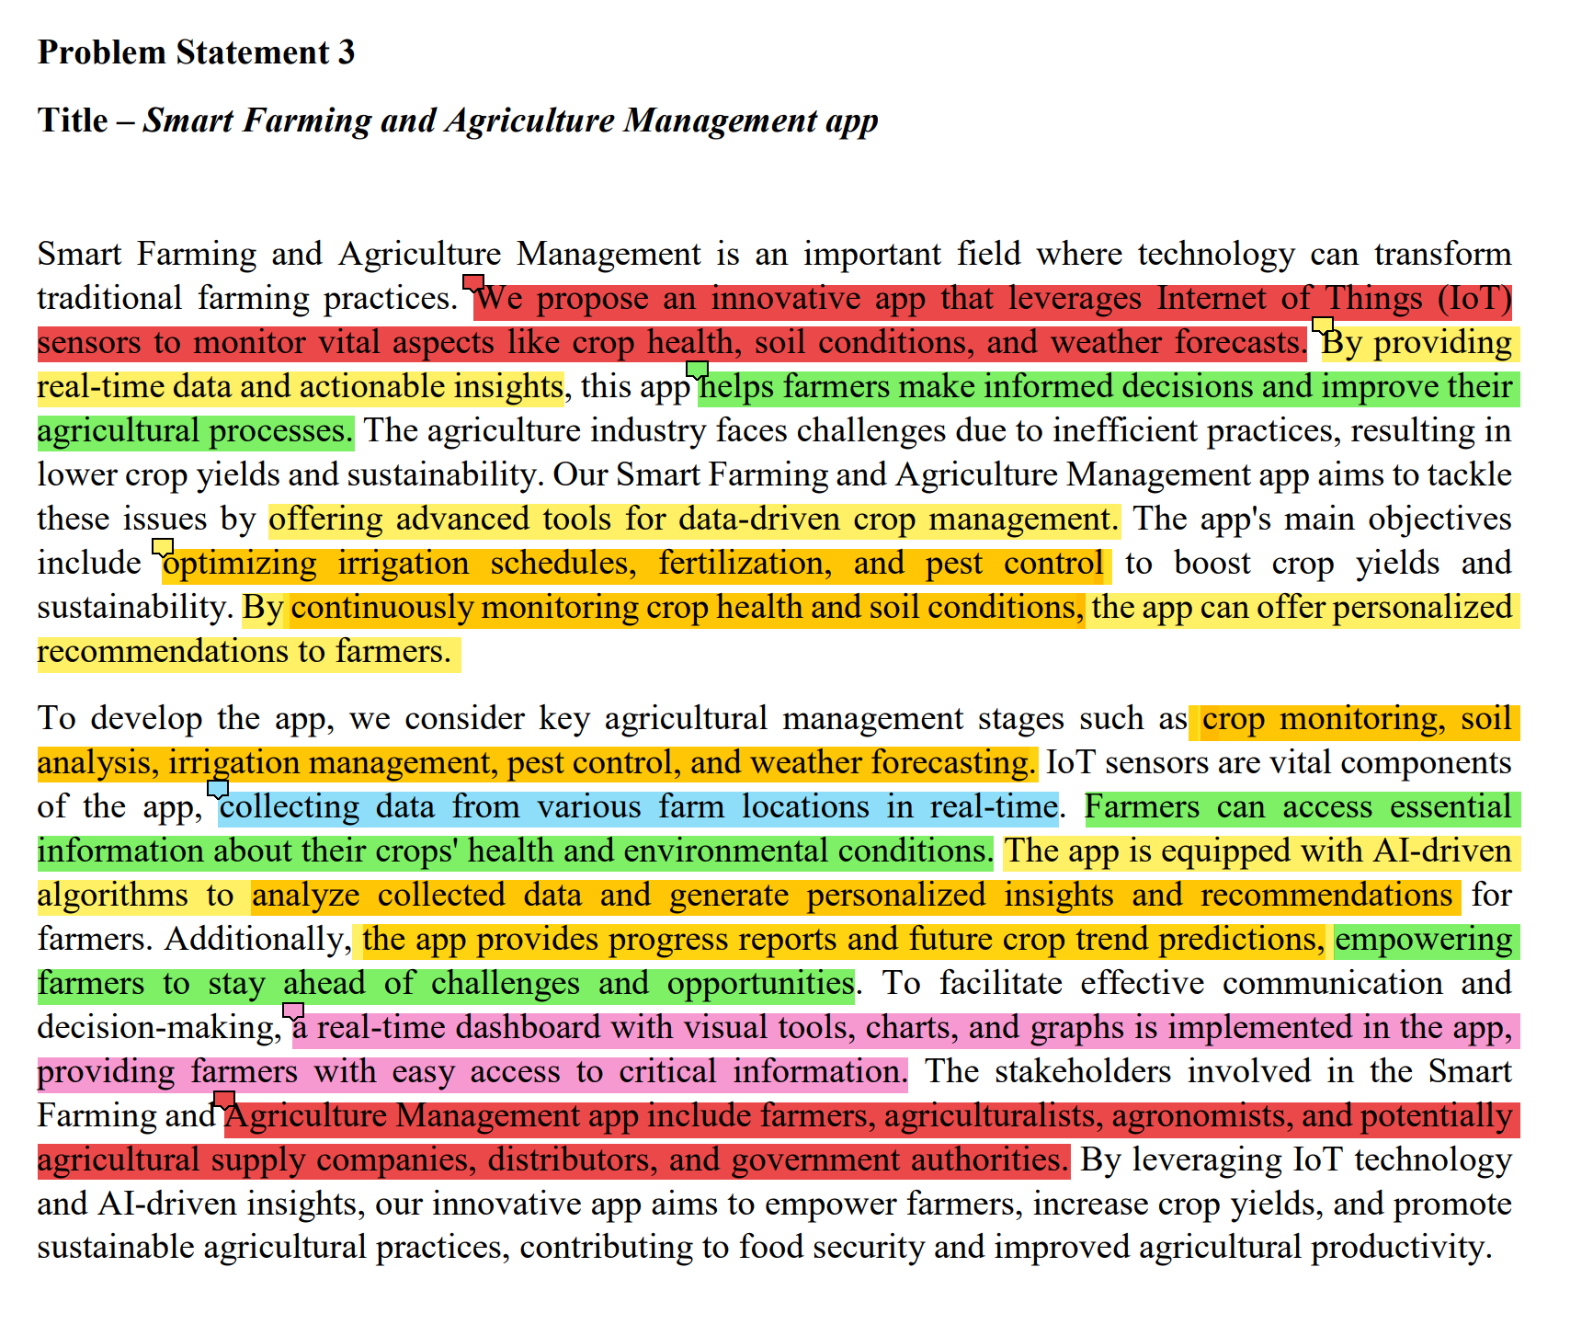
Example 1: This example shows one method used in background reading, this shows the problem being highlighted with different colours, each colour representing a set of related information. (e.g., yellow representing the functionalities of the required system, green represents the goals the system is trying to accomplish, and red representing the stakeholders)
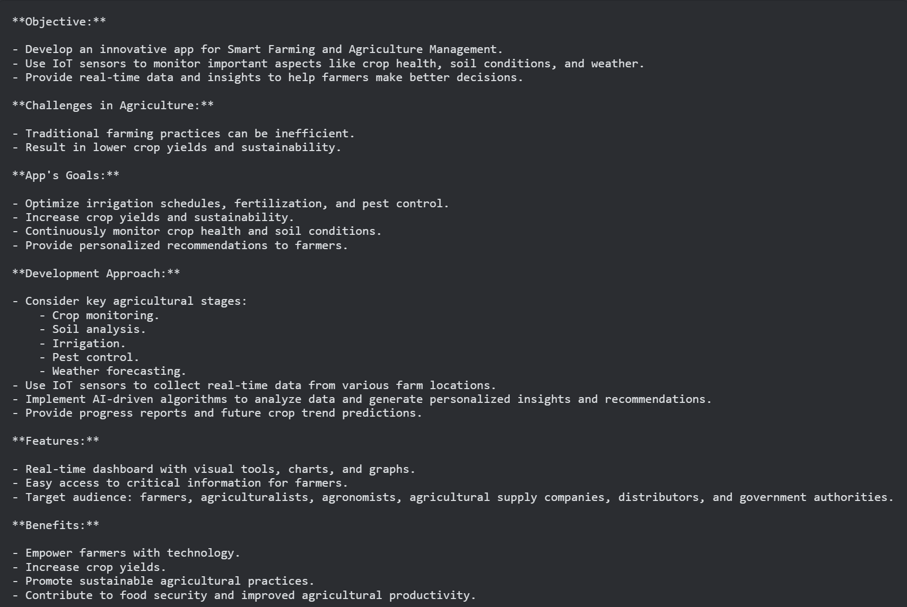
Example 2: This example is done by a different group member; it shows the findings from the problem statement written in small bullet points and what each point represents. (e.g., is it a feature, an objective, a benefit or a goal)

Group Brainstorming
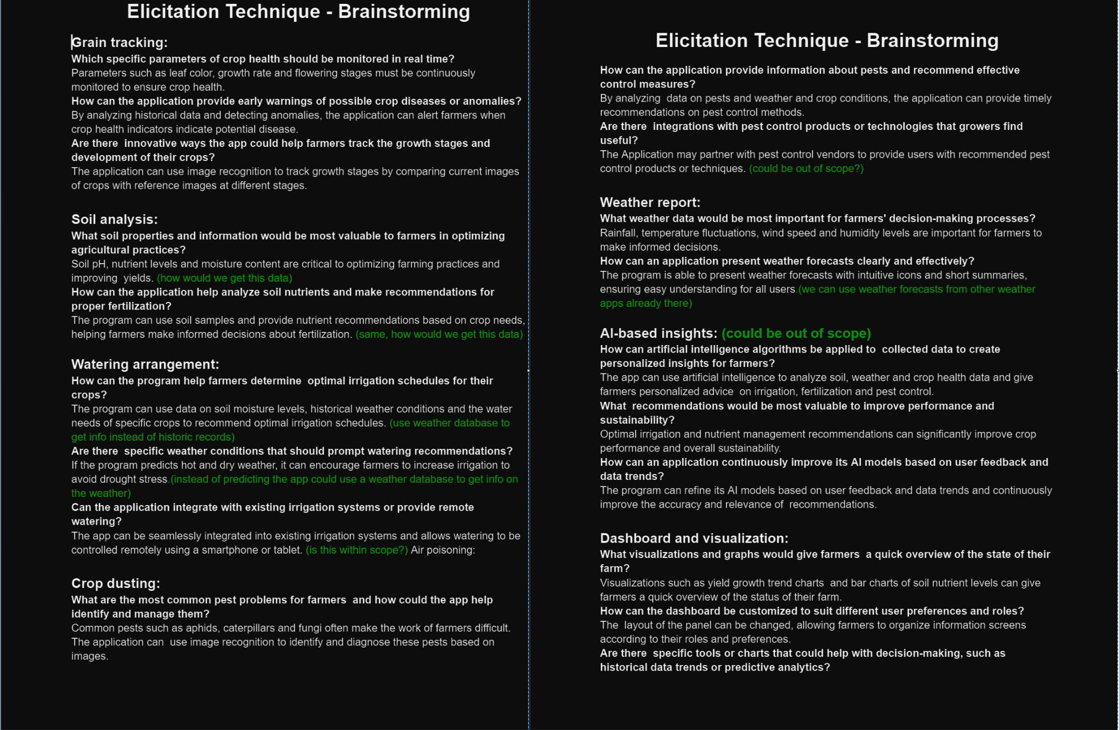
Example 3: This shows the result from the group brainstorming session, it included main topics with questions regarding these topics, then what we thought the answers for them were. From this we were able to form questions to ask the client during the meeting with them.

Client Meeting
As a result of the client meeting, our group came up with the following findings:
In our client interview, we found out that the users will not know much about making software or the farming industry. This tells us we need to make an easy-to-use app that works for people who are good with technology and those who aren't.
When we talked about using sensors in the app, the client said we don't need to get into specific sensor brands. Instead, we should focus on understanding what kinds of sensors we need for different farming situations. For weather information, we discussed getting data from outside sources or the user's regular weather app to keep things simple and accurate.
As for how the app should work, the client left it up to us. But we need to think carefully about making it easy to use and making sure people's information is kept safe (data security wise). We also need to think about whether the app can grow and change in the future. Our interview gave us a good starting point to create an app that meets the client's needs and is friendly for farmers to use, whether they're tech-savvy or not.
At the end of this phase, we had understood and refined our requirements and the scope definitions of our assignment as it was the main reason for this elicitation technique, then the project could start step by step towards the assignment.

Appendix B: Work Breakdown Structure
- Project Planning and Requirement Analysis | Days
1.1 Stakeholder Interview and Needs Assessment (With client and extras basically)  1.2 Research and Information gathering  1.3 Scope definition (Know exactly what we will be doing)  1.4 Project planning (overall/general)  1.5 Final resource gathering. | 5  8  8  13  8
- UI and system interactions design
2.1 Algorithm design  2.2 Dashboard and visual tools design (UI/UX design)  2.3 Design the interaction between the IoT sensors and database.  2.4 Design interaction between the System and the database.  2.5 Real Time reports design/contents/layout | 8  3  3  3  3
- Implementation Coding and Debugging
3.1 Sensor Configuration (Deploy sensors to right positions/rules)  3.2 Implement algorithms for system interactions with the database.  3.3 Implement interaction between the database and the IoT sensors.  3.4 Implement the visualisation for the analysed data (charts, tables, graphs, diagrams, 3.4 warnings and recommendations)  3.5 Develop a user security system for authentication and data classification. | 8  8  13  8  8
- Testing
4.1 Testing accuracy and correctness of the data gathered from sensors.  4.2 Unit testing  4.3 Testing the interactions between the database, system, and IoT sensors.  4.4 Validate the accuracy of data structures from the systems in the algorithms.  4.5 Have security testing to see vulnerabilities in the data protection.  4.6 Testing if the app is user-friendly (and easy to use by people with no technology 4.6 background.) | 5  21  8  2  3  3
- Maintenance and project closure
5.1 App Deployment  5.2 Stakeholder Meetings and Feedback  5.3 Project Review and Documentation | 5  1  3
Total | 158

Table 1: This is the established WBS (Work Breakdown Structure) for the project from planning and designing to actual implementation and system deployment.

Appendix C: Functional Requirements

Farmer
- As a farmer, I want to be able to view the weather forecast so that I know the future steps to maintain crop health and fertility rates.
- As a farmer I want to be able to view real-time data and reports on the crop health, including the crop health and disease detection, so that I can treat the crop in time.
- As a farmer I want to be able to view real-time data and reports on the crop health, soil conditions and pest detection, so that I can treat the crop in time if needed and manage the irrigation schedules.
- As a farmer I want to request personalised recommendations based on the analysed data (IoT sensors data and weather forecast), this is so I can make informed decisions to improve the agricultural process and boost crop yield and sustainability.
(Assumption: the farmer doesn’t want to view data regarding the weather specifically but, when the system gives recommendations, it considers the weather conditions while doing so)
- In order to take quick action in the case of emergencies, the farmer must receive real-time notifications and alerts predicting future critical events (such as adverse weather conditions or pest outbreaks).
(Clarification: This means that, if the system detects an emergency, it automatically sends an alert to the farmer)
- As a farmer I want to view progress reports and future crop trend predictions, in order to give me the chance to stay ahead of challenges and opportunities.
- As a farmer I want to be able to customise the app’s homepage to include my preferred charts, schedules and other analysed data, in order to make the app more efficient to use.

Government Authorities
- In order to be able to adequately plan for the future, the government authorities should be able to view limited or generalised data for the farm.
(Clarification: limited data in this context means, what the farmer approves to share with these third parties)

Academic institutions
- As academic institutions, we want to be able to access data regarding the crop and soil, in order to be able to make studies and research to help improve the farming industry.
(Clarification: limited data in this context means, what the farmer approves to share with these third parties)

Additional assumptions
- Users are expected to have access to the Internet to update real-time data and interact with the app.
- The application must comply with data protection rules and protect user data appropriately.
- The application should take into account regional and geographic variation in plant species, climate and agricultural practices to provide accurate recommendations.
- Users may require training and support to effectively use the app's features and interpret the information and recommendations provided.
- Integration with external systems such as agricultural supply companies and government agencies may require their collaboration and API access.

Appendix D: Non-Functional Requirements

Performance
- The app must retrieve the report when prompted by the user after 20 seconds from being prompted.
- The system must run on a minimum of 200MB of RAM when doing the basic tasks like displaying the UI or during communication with other users.
- The system must send warnings and recommendations to the user within 15 seconds of being prompted to do so or, after detecting emergency circumstances.

Reliability
- The system must provide readings for the data received from the IoT sensors with accuracy of 99.5%.
- The system must display the requested data structures (graphs, charts and other analytic representations) with 99.9% accuracy.
- The system must not fail in retrieving requested data from the IoT sensors more than 1 time every 250 requests.

Usability
- The system must allow the user to display their preferred readings and data structures (graphs, charts and tables) within 2 screen touches.
- The system must display at most 2 types of data structures on 1 screen to maintain readability.
(Clarification: Depending on the screen size of the phone, 1 screen means without the need to scroll to view the complete data structure being displayed).

Security
- The system must ensure all data being transmitted between the sensors and the system is encrypted using protocols like SSL to prevent unauthorised access to the user’s data.

Interoperability
- The system must run on both Android operating systems and IOS.
- The system must be able to run on the average specs for mid-range phones, most importantly, 4GB - 6GB RAM and 1.8GHz to 2.4GHz clock speed CPU.
(Assumption: we assume that not all farmers could not have high-range phones.)

Localisation
- The user interface must be capable of displaying the measurement units used in the analysed data and recommendations in both the metric system and imperial system.

Appendix E: UML Diagrams
This is a draft of the different use cases extracted from the functional requirements.

- Log data IoT sensors/DB Farmer/DB through using store data
- Enter Data Farmer//DB through using store data
- Store data DB
- Get data Weather/Db Farmer/Db
- View data Farmer
- Ai analyse data Interacts with the whole system through ‘uses’ relationships
- Get recommendations Farmer uses analyse data
- Send notification
- Make recommendation Extends send notification
- View limited data Government/Academics

Logging data involves constantly updating data (through IoT systems or a farmer checking sensors daily)
Enter Data involves farmers entering large sets of data at once (for example initialisation data such as when a farmer first registers their farm and enters in all the data associated with that such as location, crops, dimensions, etc.)

Use Case UML Diagram
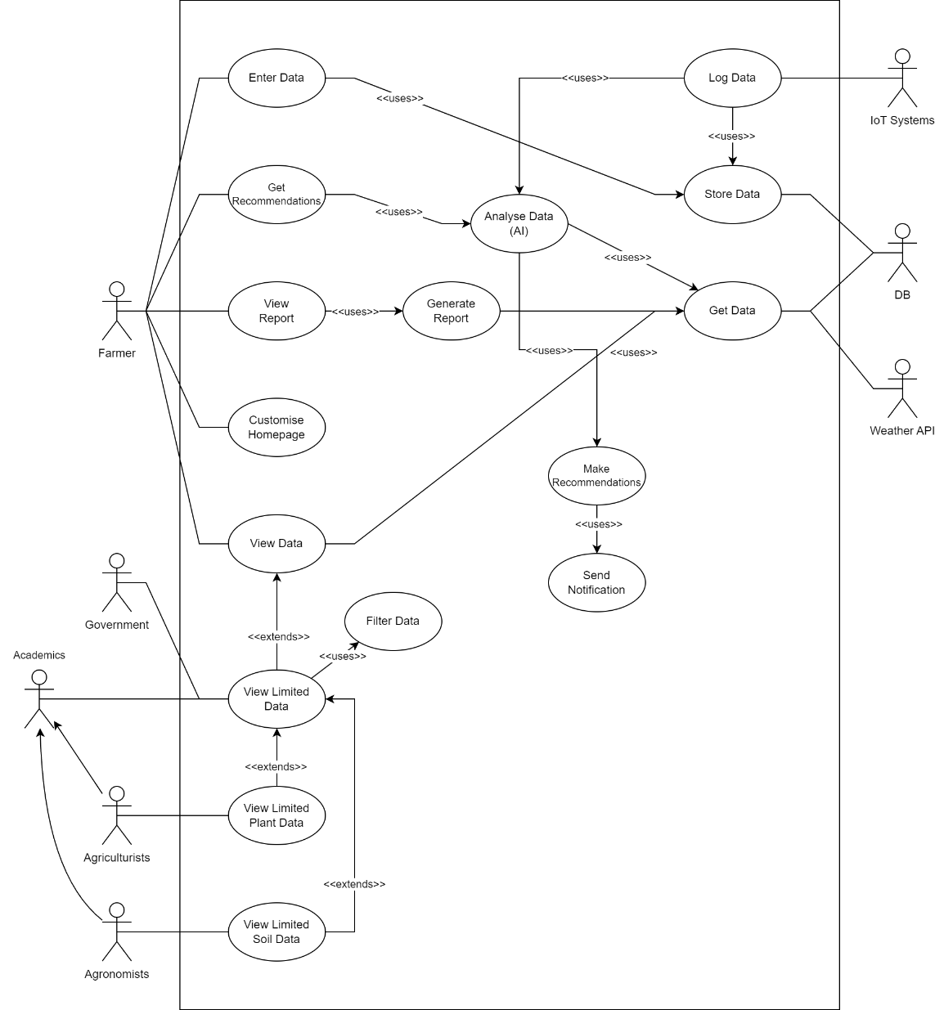

Sequence UML Diagrams

Enter Data
We are assuming that any data change will trigger a data analysis cycle and may produce new recommendations.
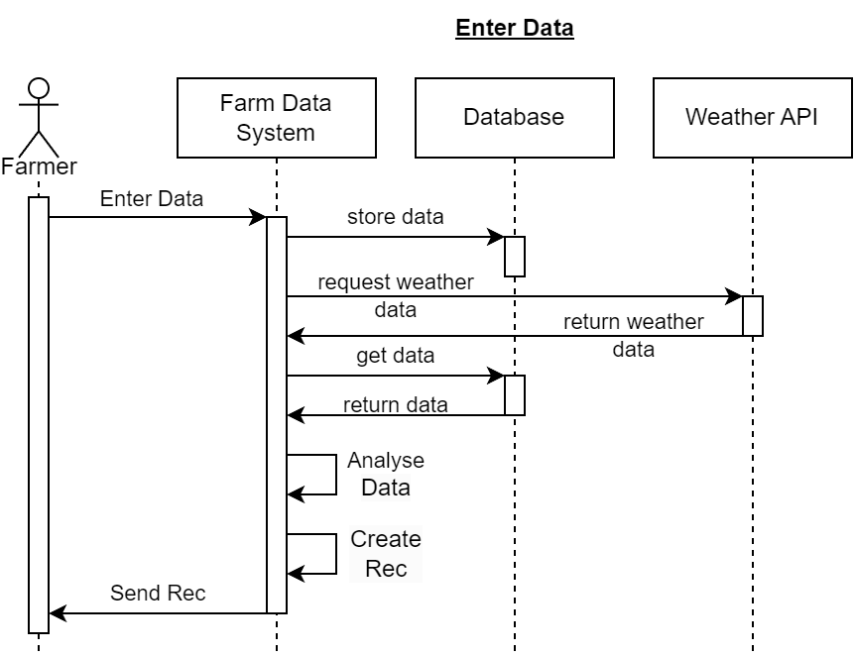

View Data
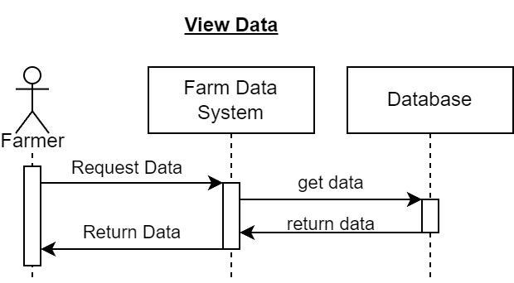

Log Data
We are assuming that the IoT system is reporting data as it changes and not at request. This means that the most recent data will always be available in the database
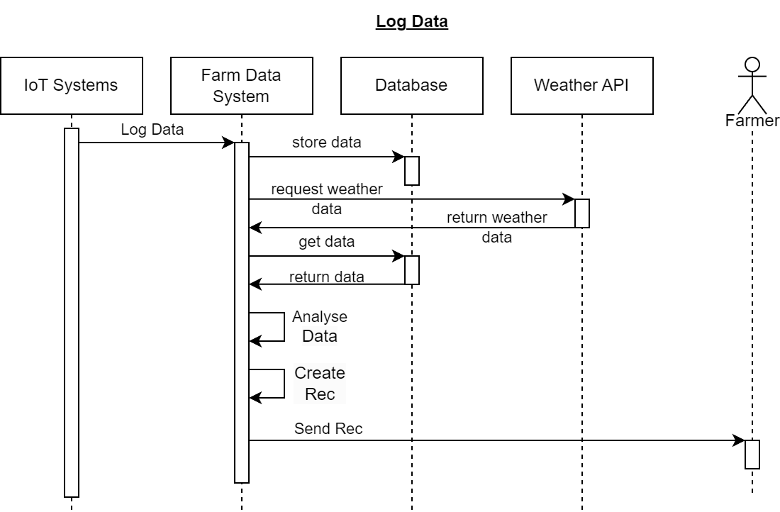

Request Recommendations
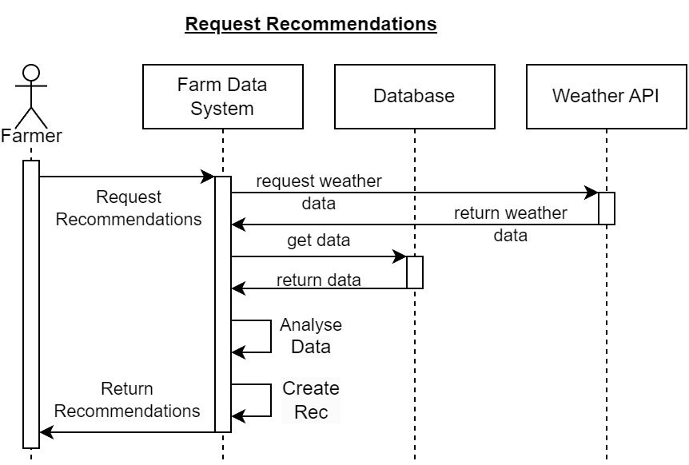

Get Report
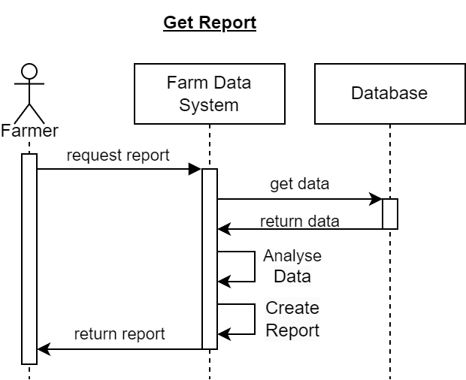

View Limited Data - Government
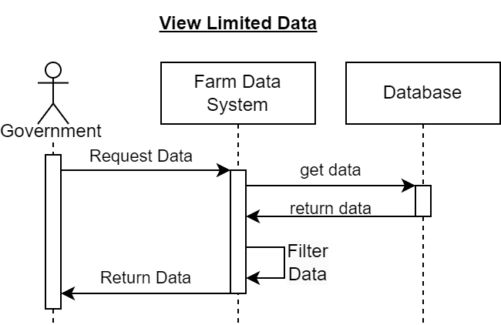

View Limited Data - Academics
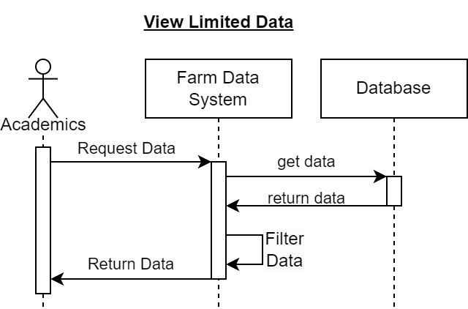

Activity UML Diagram

Customise Homepage
We are assuming that the data relevant to customisation of the homepage will be small and so it can be stored directly in the application rather than in the database.
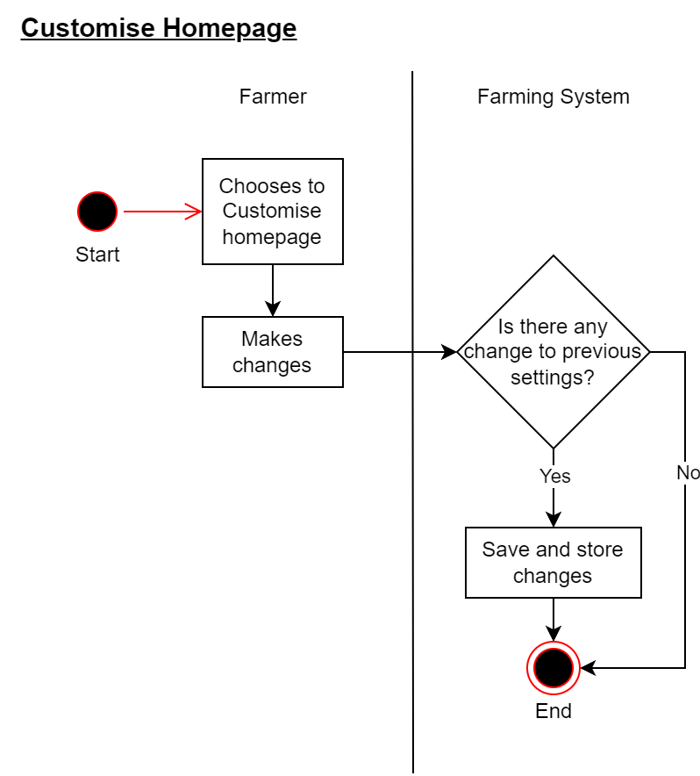

Log Data
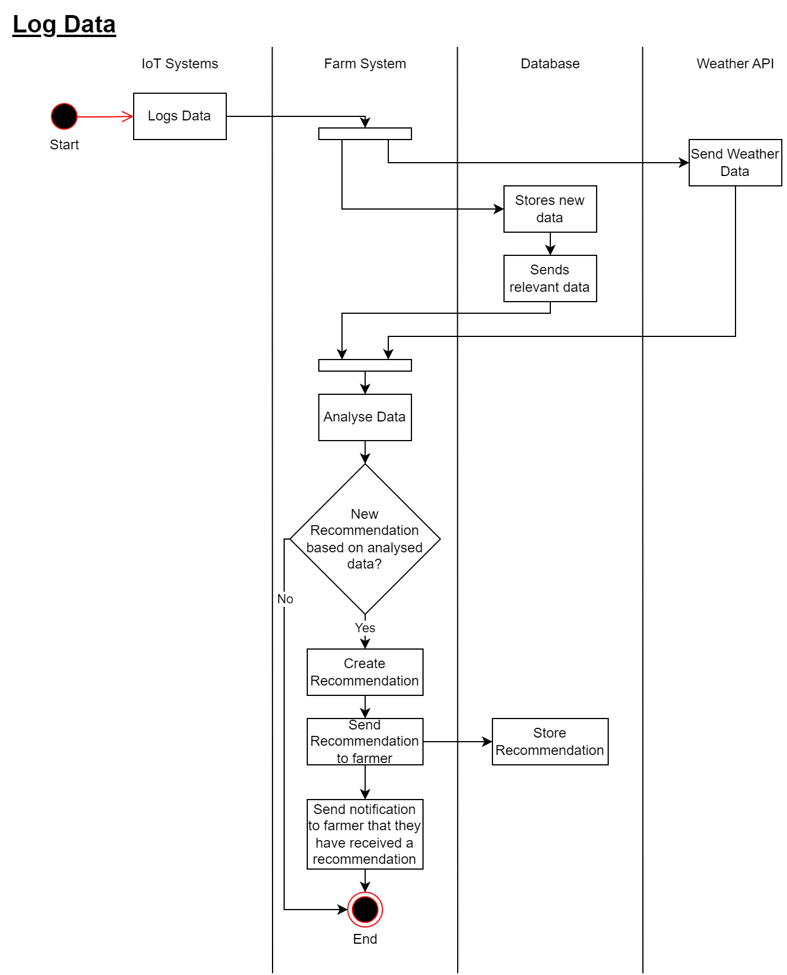

Request Report
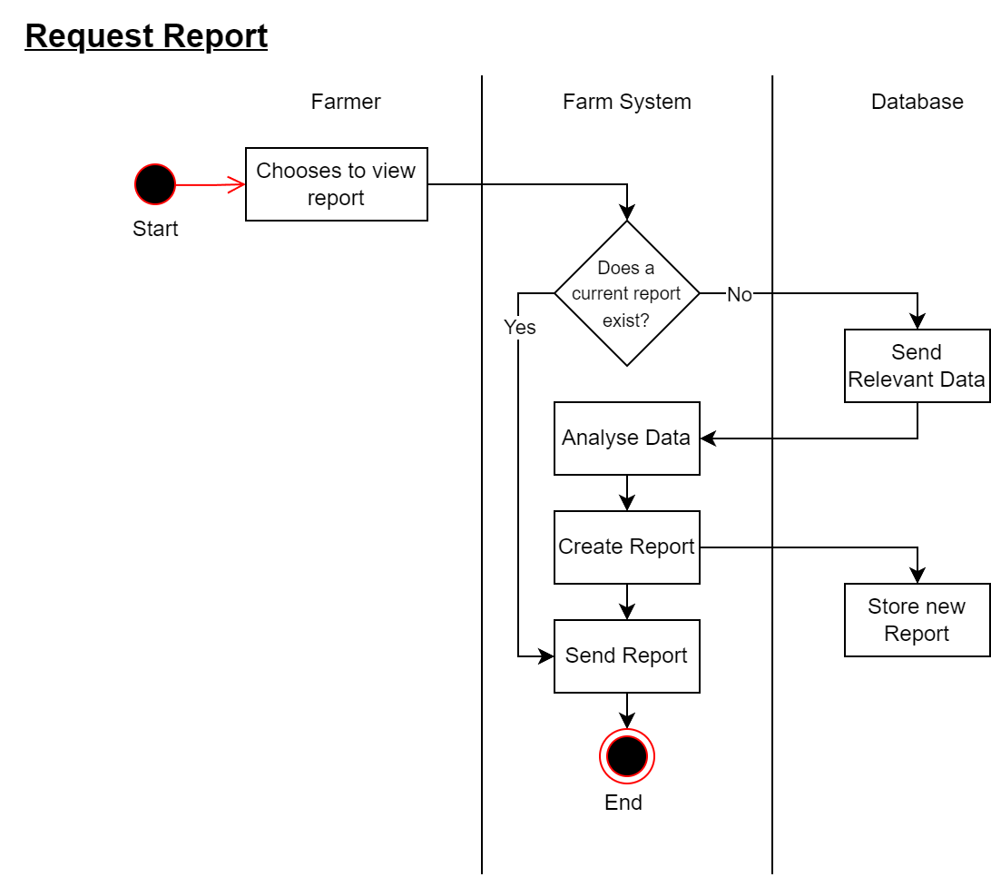

Request Recommendation
We are assuming that the data related to the IoT sensors is already stored in the database.
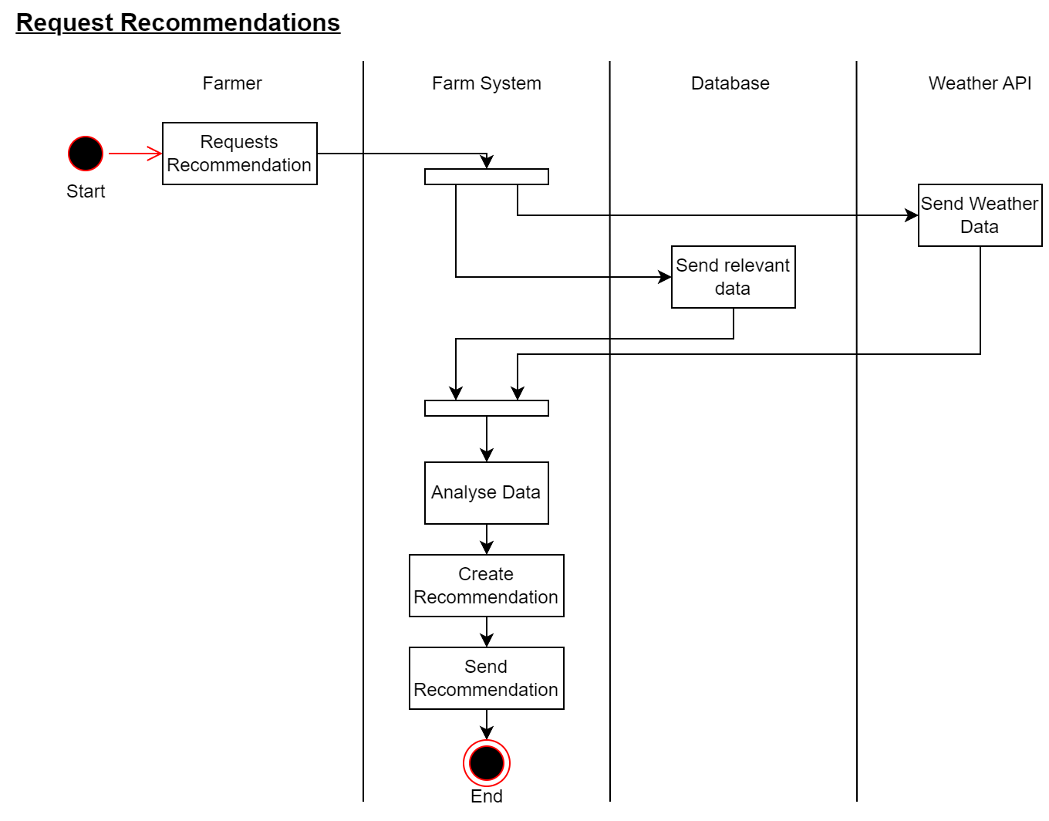

Enter Data
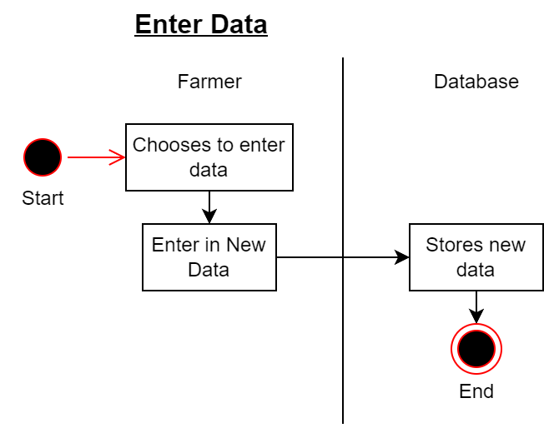

View Limited Data
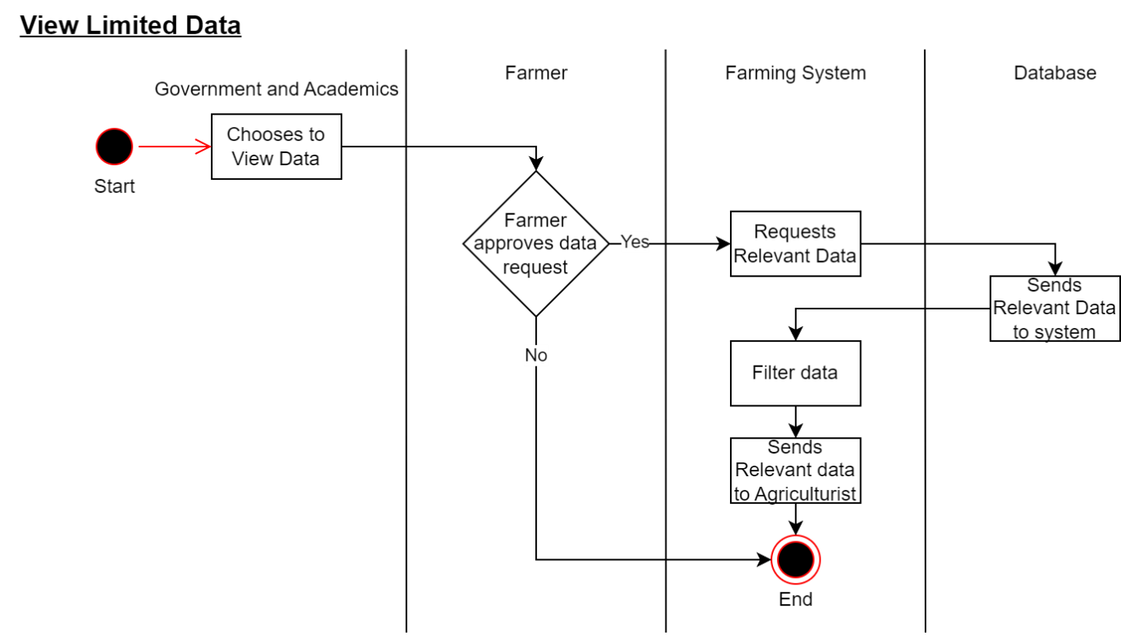

View Limited Soil Data
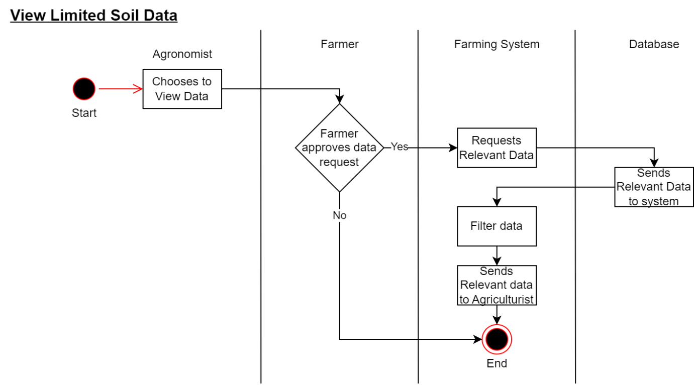

View Limited Plant Data
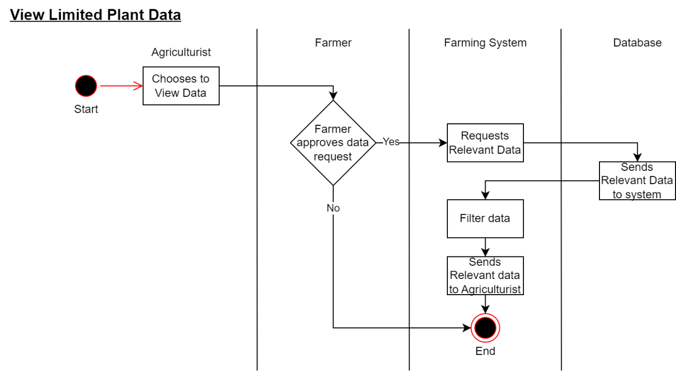

View Data
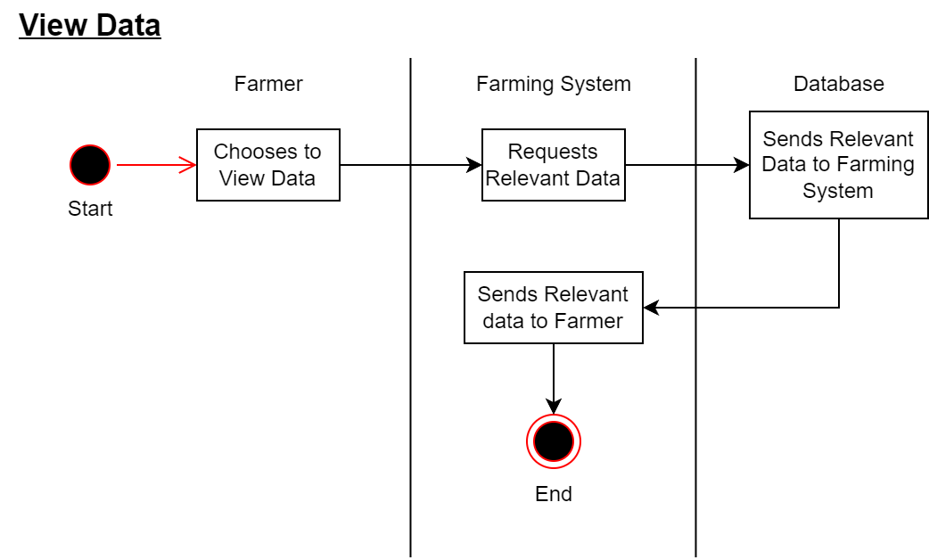

State UML Diagram:

Farming System State Diagram
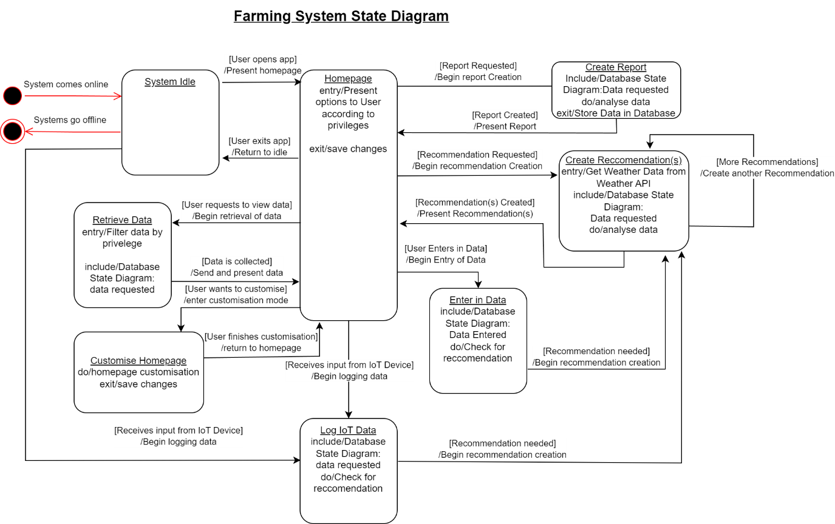

Database State Diagram
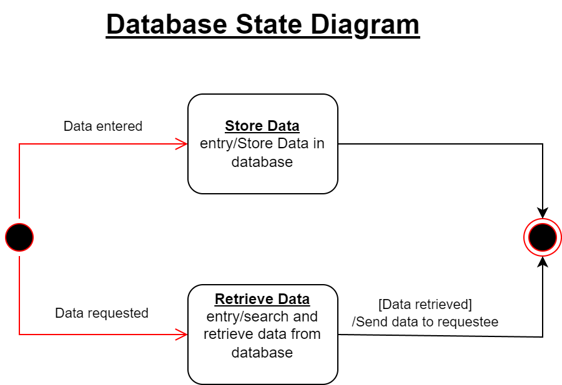

Appendix F: Agile and Scrum Planning
Tasks and Sub-tasks | Estimated Complexity (Complexity) | Sprint  (Weeks)
1.0 Information Gathering and Problem Statement Analysis.
1.1 individual Info gathering through reading existing documents. | 3 | 1
1.2 brainstorm through a focused group meeting. | 2 | 1
1.3 prepare for and interview the client. | 2 | 1
1.4 Combine all gathered information from the three elicitation techniques and review it. | 1 | 2
2.0 Construct WBS
2.1 Layout all the tasks for the assignment based on the info gathered from step 1 and review them. | 3 | 2
2.2 Write Down all the necessary sub-tasks to complete each task and review them. | 5 | 2
2.3 Construct WBS and assign an estimated duration. | 2 | 2
3.0 List of all Functional and Non-Functional Requirements.
3.1 Based on the info gathered in step 1, list down all the Functional Requirements with assumptions. | 8 | 2
3.2 List all the Non-Functional Requirements for the app with assumptions (I think we should have 10). | 5 | 3
3.3 Review all of the FR and NFR and modify if required. | 2 | 4
4.0 Construct All Modules
4.1 UML Use Case Diagram | 5 | 4
4.2 UML Sequence Diagram | 8 | 4
4.3 UML Activity Diagram | 8 | 4
4.4 UML State Diagram | 8 | 4
5.0 Construct Report Document.
5.1 Write the main section of the report. | 3 | 4
5.2 Include all References and appendices with sufficient commentary. | 2 | 4
5.3 Review and edit report document. | 1 | 4
5.4 Final formatting for the report document. | 1 | 4
Total | 69
Table 2: This table is the Agile and Scrum planning table; it has the breakdown of tasks and subtasks required to complete this assignment. These tasks were then divided between the group members.
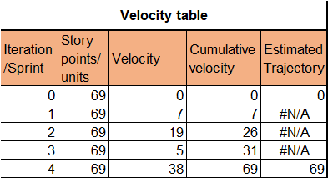
Table 3: This table included all the necessary data to create a burn-up chart which were, the total story points, the velocity, which is the measure of the teams’ rate of progress, the cumulative velocity and the estimated trajectory.

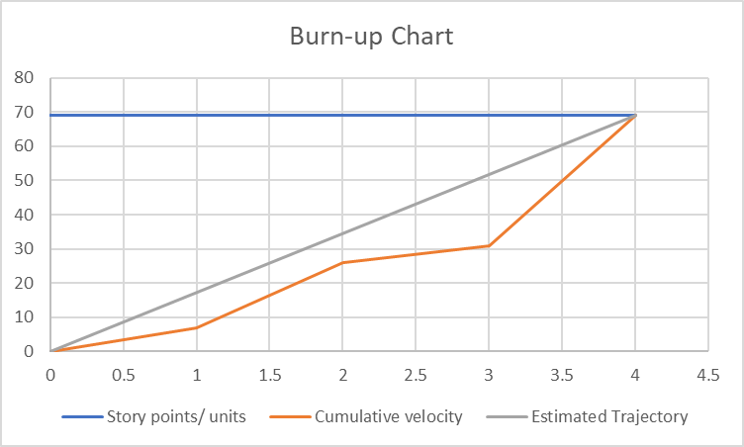
Chart 1: Burn-up chart for all four sprints.
This chart illustrates that progress during the initial two sprints was somewhat slower than the initial estimates, but it was still within a reasonable range. However, by the time Sprint 3 rolled around, there was a notable decrease in the rate of progress. This necessitated an uptick in workload during the final week in order to bridge the gap between the actual progress and the estimated progress, ensuring that the assignment could be completed on schedule.

