Software Requirements Specifications
For

Smart Farming and Agriculture Management app
Version 1.0
Prepared by:
Mouktada Salman 20640266
Ahmed Adnan Youseif 21467369
Thomas Alexander White 19155805
Mathew John Dorosz 19181376
Mustafa Danish 20904894
Curtin University
18/10/2023

Contents
Chapter 1: Introduction 3
1.1 Purpose 3
1.2 Scope 3
1.3 Overview 3
Chapter 2: General Description 4
2.1 Product Perspective 4
2.2 Product Functions 4
2.3 User Characteristics 5
2.4 Operating Environment 5
2.5 Assumptions and Dependencies 5
Chapter 3: Specific Requirements 6
3.1 Functional Requirements 6
3.1.1 Requirements of IoT and Management of Data 6
3.1.2 Requirements for Weather Forecast and Monitoring 7
3.1.3 Requirements for Recommendations and Alert System. 8
3.1.4 Requirements for Report Management System 9
3.1.5 Requirements for Government and Academic Institutions 10
3.2 External Interface Requirements 12
3.2.1 User Interfaces 12
3.2.2 Hardware Interfaces 14
3.2.3 Software Interfaces 14
3.3 Other Non-Functional Requirements 15
3.3.1 Performance Requirements 15
3.3.2 Security Requirements 15
3.3.3 Software Quality Attributes 16
3.3.3.1 Reliability 16
3.3.3.2 Usability 16
3.3.3.3 Interoperability 17
3.3.3.4 Localisation 17
3.3.4 Other Requirements 17
Database 17

Chapter 1: Introduction

1.1 Purpose
This document describes the software requirements for a smart farming and agriculture management app. It is intended for the designers, developers and maintainers of the app.

1.2 Scope
The function of the smart farming and agriculture management app is to leverage Internet of Things (IoT) sensors to monitor vital aspects of crop health and soil conditions by providing real time data and actionable insights. This will help farmers improve their agricultural process by making informed decisions.

1.3 Overview
The remainder of this document is structured in the following manner: Firstly, we will provide definitions for key terms. In Section 2, a comprehensive overview of the smart farming and agricultural management app will be presented. Section 3 will outline the specific functional requirements, external interfaces, and performance criteria for the app.

Chapter 2: General Description

2.1 Product Perspective
The farming and agricultural management app does not work independently. The app has to work with IoT sensors deployed in farms, in addition to weather API’s and a database to store collected data. There are clearly defined interfaces for the defined systems.

2.2 Product Functions
The system should control the farm details (health, condition, and/or information), weather forecasts, IoT, customisation of recommendations and profiles, etc.

- After deploying the IoT sensors within the farm, the app should get immediate data related to crop health, soil conditions, and real-time weather data.

- Using AI-driven algorithms, the app (should I call it software or app) should collect and process the data.

- Farmers will be alerted with recommendations for disease control for them to take quick actions.

- Real-time weather forecasts are conducted within the system to also help with the alerts and recommendations for extreme weather events.

- For an easier use of the app, we provide personalized recommendations for pest control, soil health, etc.., as well as personalized profile themes.

- When farmers use the dashboard, they can monitor their crop’s progress over time, with built in visual tools like charts and graphs for better decision-making and understanding.

- If farmers agree to share their farm data, then government and academic institutions will have access to special reports generated from the farms to help with advanced studies.

2.3 User Characteristics
There are several potential users for the app:

- Farmers
Farmers must be able to easily navigate through the app, they must be able to freely customize different aspects of the UI, and also have the ability to view generalized or specialized data reports regarding crop and soil health. The farmers must have complete access to any information related to their farms and must also consent to the disclosure of any information related to their farms.

- Government
Government institutes can access limited information regarding the farms using the system. These limitations must be agreed upon by farmers.

- Academics
Academics like agriculturists and agronomists can also access limited data regarding the farms based on the farmers’ concession.

2.4 Operating Environment
The software will operate on smartphones that run IOS and Android. For phones that run on IOS operating systems, the app must run on IOS 13 and above. As for Android operating systems, the app must run on Android 9(Pie) and above. The app must not intervene with the operation of any other software on the smartphone.

2.5 Assumptions and Dependencies
For Government Authorities and Academic Institutions, they depend on the farmer’s choice. Which is whether they give permission for their reports to be shared or not.

Assumptions were made next to their appendices accordingly.

Chapter 3: Specific Requirements

3.1 Functional Requirements

3.1.1 Requirements of IoT and Management of Data
Functional Requirement 1
The system must be able to collect real-time data from IoT sensors monitoring crop health. (Assignment 1)

Functional Requirement 2
The system must upload the stored data to a centralized database for storage. (Assignment 2)

Functional Requirement 3
The system must have an easy-to-use dashboard for farmers to track crop health data in real time. (Assignment 1)

Functional Requirement 4
The system must have dashboards that show information such as humidity, temperature and diagnosis. (Assignment 1)

Functional Requirement 5
The system must provide historical reports on crop health, including incidence and disease history. (Assignment 2)

Functional Requirement 6
The system must be continuously monitoring the crop moisture levels using the IoT sensors. (Assignment 2)

Functional Requirement 7
The system must be using the monitored crop moisture levels to make sure that they are watered at the right times. (Assignment 2)

3.1.2 Requirements for Weather Forecast and Monitoring
Functional Requirement 8
The system must analyse IoT sensor data and include weather forecasting. (Assignment 1)

Functional Requirement 9
The system must provide individualized recommendations to farmers based on data analysis. (Assignment 1)

Functional Requirement 10
The system must provide recommendations and include actions to improve agricultural practices, increase productivity and ensure sustainability. (Assignment 1)

Functional Requirement 11
The system must give up-to-date weather forecasts for the farmers to plan ahead for their activities. (Assignment 2)

3.1.3 Requirements for Recommendations and Alert System.
Functional Requirement 12
The system must have an alert mechanism to notify farmers and notify farmers of critical events. (Assignment 1)

Functional Requirement 13
The Warnings must cover emergencies such as adverse weather, pests, or sudden deterioration of crop health. (Assignment 2)

Functional Requirement 14
The Warnings must be sent to farmers in real time through notifications through the app. (Assignment 2)

Functional Requirement 15
The user interface must be customizable for farmers to customize recommendations or receive advice that aligns with certain goals. (Assignment 1)

Functional Requirement 16
The system must provide farmers the ability to customize the homepage of the application from a range of themes. (Assignment 1)

Functional Requirement 17
The Customization options must include selecting charts, charts, and specific analysed data to be displayed. (Assignment 1)

Functional Requirement 18
The process must be streamlined, allowing farmers to focus on the most useful data. (prioritize data from most urgent on top, to least urgent at the bottom), (Assignment 2)

Functional Requirement 19
The system must include user support features like in-app guides, tutorials, and access to a knowledge base. (Assignment 2)

3.1.4 Requirements for Report Management System
Functional Requirement 20
The system must generate progress reports for farmers to monitor their crop progress. (Assignment 1)

Functional Requirement 21
The system must generate a growth report which includes historical data and a forecast of future growth. (Assignment 1)

Functional Requirement 22
The system must provide farmers the option to set the frequency of report updates (e.g., daily, weekly, monthly). (Assignment 2)

Functional Requirement 23
The system must support the export of progress reports in various formats like PDF and Excel for sharing with stakeholders, investors, or for record-keeping. (Assignment 2)

3.1.5 Requirements for Government and Academic Institutions
Functional Requirement 24
The system must have and make generalized data of each farm without revealing sensitive data of farmers etc, (Assignment 2)

Functional Requirement 25
The system must store these generalized data in a separate table of Database available for government authorities. (Assignment 2)

Functional Requirement 26
The government authorities must be able to retrieve the data from their own database table to view and adequately plan for the future. (Assignment 1)

Functional Requirement 27
The system must keep a record of each time the government uses for a specific period, allowing for trend analysis and long-term planning (Assignment 2)

Functional Requirement 28
The system must give a choice for farmers for them to decide whether or not they want to share a general summarization of their farm data. (Assignment 2)

Functional Requirement 29
The system must summarize data on crop and soil from farms that give permission for their data to be used in later research and studies. (Assignment 1)

Functional Requirement 30
The data must be then put into a separate table of database, could be the same one for the government authorities for academic institutions to use. (Assignment 2)

Functional Requirement 31
The academic authorities must be able to retrieve the data from their own database table to study and research about. (Assignment 1)
Functional Requirement 32
The system must establish clear policies and guidelines for academic data access, including data usage restrictions. (Assignment 2)

3.2 External Interface Requirements

3.2.1 User Interfaces
Our app will have a few different interfaces to view and manage different aspects of the system. Some examples are included below.

Main dashboard/live data page.
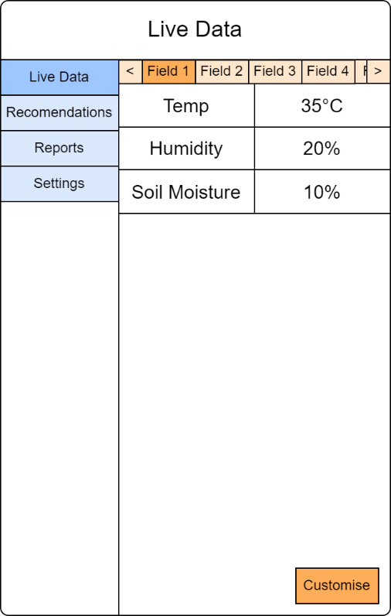

List of recent recommendations.
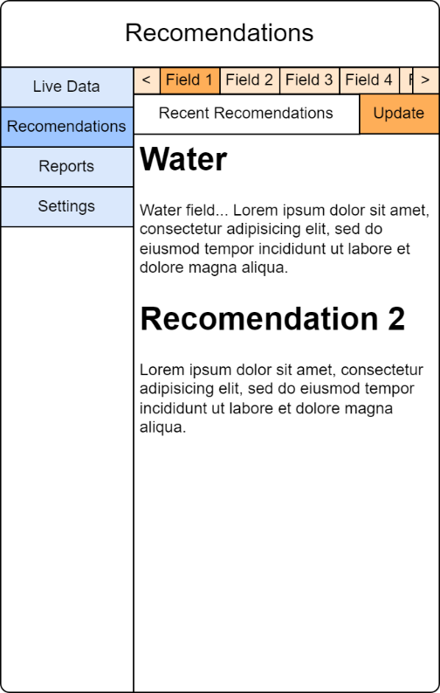

Settings page to manage the system.
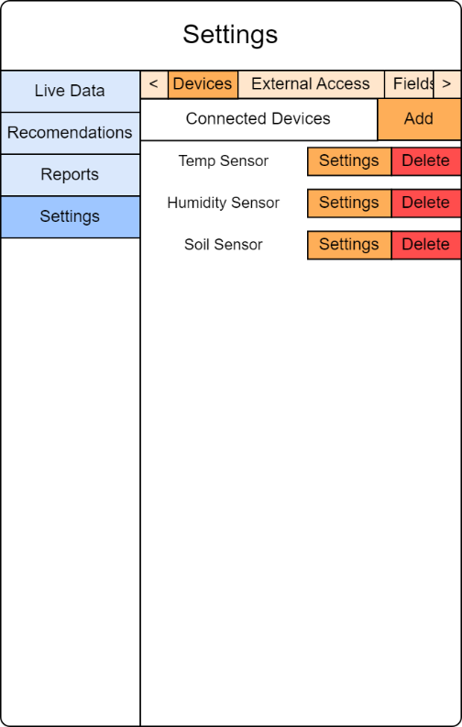

3.2.2 Hardware Interfaces
Our app is developed for mobile devices, with users on Android and iOS platforms having access to it. It connects to IoT sensors and uses a set of communication protocols to collect and control data in real time. Artificial intelligence-driven algorithms analyse data, provide insights, and forecast future crop trends, while a real-time dashboard enables effective communication and decision-making.

3.2.3 Software Interfaces
The app communicates with a MongoDB database for data storage, runs on the Android and iOS platforms, for best use we recommend the use of Android 9(pie) and above or IOS 13 and above. The app contains multiple libraries and external services for data visualization and communication and uses OAuth 2.0 for user authentication for government agencies and academic institutions. For real-time data interaction and with external weather services and IoT sensors, it uses RESTful APIs and MQTT. Then the app can provide users with real-time insights, personalized recommendations, and up-to-date agricultural data, improving the entire user experience and functionality.

3.3 Other Non-Functional Requirements

3.3.1 Performance Requirements
Performance Requirement 1

The app must retrieve the weather forecast for a week in advance within 5 seconds of receiving the prompt from the user.

Performance Requirement 2

The system must run on a minimum of 200MB of RAM when doing the basic tasks like displaying the UI or during communication with other users.

Performance Requirement 3

The system must send warnings and recommendations to the user within 15 seconds of being prompted to do so or, after detecting emergency circumstances.

3.3.2 Security Requirements
Security Requirement 1

The system must ensure all data being transmitted between the sensors and the system is encrypted using protocols like SSL to prevent unauthorized access to the user’s data.

3.3.3 Software Quality Attributes

3.3.3.1 Reliability
Reliability Requirement 1

The system must provide readings for the data received from the IoT sensors with accuracy of 99.5%.

Reliability Requirement 2

The system must display the requested data structures (graphs, charts and other analytic representations) with 99.9% accuracy.

Reliability Requirement 3

The system must display at most 2 types of data structures on 1 screen to maintain readability (Depending on the screen size of the phone, 1 screen meaning without the need to scroll to view the complete data structure being displayed).

3.3.3.2 Usability
Usability Requirement 1

The system must allow the user to display their preferred readings and data structures (graphs, charts and tables) within 2 screen touches.

Usability Requirement 2

The system must display at most 2 types of data structures on 1 screen to maintain readability (Depending on the screen size of the phone, 1 screen meaning without the need to scroll to view the complete data structure being displayed).

3.3.3.3 Interoperability
Interoperability Requirement 1

The system must run on both Android operating systems and IOS.

Interoperability Requirement 2

The system must be able to run on the average specs for mid-range phones, most importantly, 4GB - 6GB RAM and 1.8GHz to 2.4GHz clock speed CPU.

Interoperability Requirement 3

(in the external interface requirements, we specify what hardware we are using, e.g., the type of RAM and the type of CPU)

Assumption:
We assume that not all farmers could not have high-range phones.

3.3.3.4 Localisation
The user interface must be capable of displaying the measurement units used in the analysed data and recommendations in both the metric system and imperial system.

3.3.4 Other Requirements

Database
The app must use several tables as well as several data formats within the database, for different purposes such as moisture levels, weather forecasts, and recommendations. Farmers will always have access to the main table including every minor data that exists and retrieved from sensors, while Government Authorities and Academic Institutions will have a separate table which will only include general reports about the data that they can retrieve.

