Assignment 2
Requirements Engineering

Smart Farming and Agricultural Management App
Mouktada Salman 20640266
Ahmad Adnan Youseif 21467369
Thomas Alexander White 19155805
Mathew John Dorosz 19181376
Mustafa Danish 20904894
Curtin University
19/10/2023

Contents
1. Methodology 3
2. Discussion 3
3. Conclusion 3
Appendix A: Model Diagrams 5
Appendix A.1: UML Class Diagram 5
Appendix A.2: Goal Modelling 6
Appendix A.3: Strategic Dependency Model 9
Appendix A.4: Strategic Rationale Diagram 11
Appendix B: Product Backlog and Burn Down/Burn Up Charts 12
Appendix B.1: Product Backlog 12
Appendix B.2: Burn Down 14
Appendix B.3: Burn Up 15
Appendix B.4: Burn Up (Scope Change) 16
Appendix C: System Requirements Specifications 17
Appendix D: Mockup Diagrams 17

Methodology
The process we undertook to identify and document requirements for the Smart Farming and Agricultural Management App involved a series of steps. In the beginning, we carefully reviewed the gathered information in assignment 1, identifying the accurate requirements and those needing adjustments in addition to the missing requirements that need to be added. To accomplish this, we sought feedback from our tutor and engaged in group discussions where we agreed on necessary changes.

Then, we utilized a goal modeling diagram in conjunction with both SD and SR I* diagrams to gain a better understanding of the interactions between the different actors involved. This helped in further refining the Software Requirements Specification (SRS) to make sure it accurately aligned with the system's objectives.

Next, we continued to extract detailed functional requirements as well as non-functional requirements such as performance, security, and usability. To validate these requirements, we engaged other group members to validate their accuracy.

Finally, we compiled all the requirements into a comprehensive Software Requirements Specification (SRS) document, which provided a complete description of the project's goals, scope, functional and non-functional requirements.

Discussion
Throughout the analysis process, we faced various challenges and limitations. One notable issue was the difficulty in differentiating between functional requirements and features, as well as determining the level of detail required for functional requirements to be considered adequate. Additionally, identifying non-functional requirements like performance and reliability presented challenges, mainly due to uncertainties regarding the capabilities of the farmers' devices and the evolving nature of technology.

However, by consulting our tutor and engaging in group discussions, we successfully addressed these challenges and learnt valuable lessons. One important lesson was the importance of asking questions, even if they appeared overly detailed or repetitive, emphasizing the need to clarify misunderstandings, which was present in distinguishing between functional requirements and features as mentioned earlier. Another key takeaway was the importance of continued discussions with fellow group members throughout the progress, as these exchanges were essential in identifying potential misunderstandings and mitigating errors in the Software Requirements Specification (SRS).

Conclusion
In conclusion, our approach to the analysis phase enabled us to effectively identify, present, and document the project's requirements. In spite of the challenges and limitations our group encountered, we adapted and gained valuable insights, eventually leading to a more flexible and efficient Software Requirements Specification (SRS). Our comprehensive understanding of the project's requirements and the thorough specifications we managed to create effectively direct the development process by following these methodologies.

Appendix A: Model Diagrams

Appendix A.1: UML Class Diagram
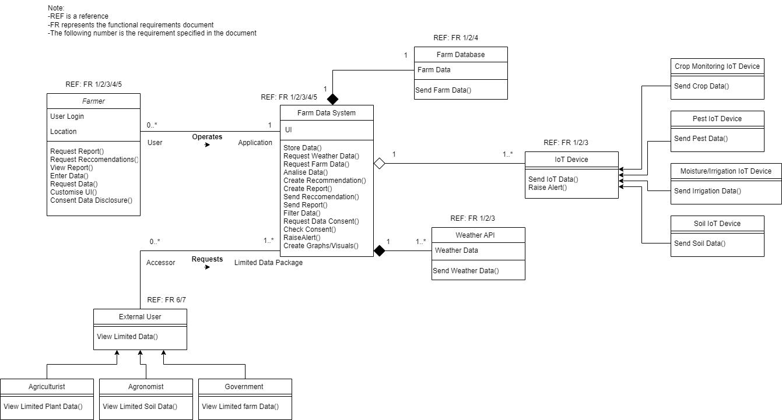
Figure 1: UML Class Diagram to illustrate the attributes, methods and relationships between classes and objects of the system.

Appendix A.2: Goal Modelling
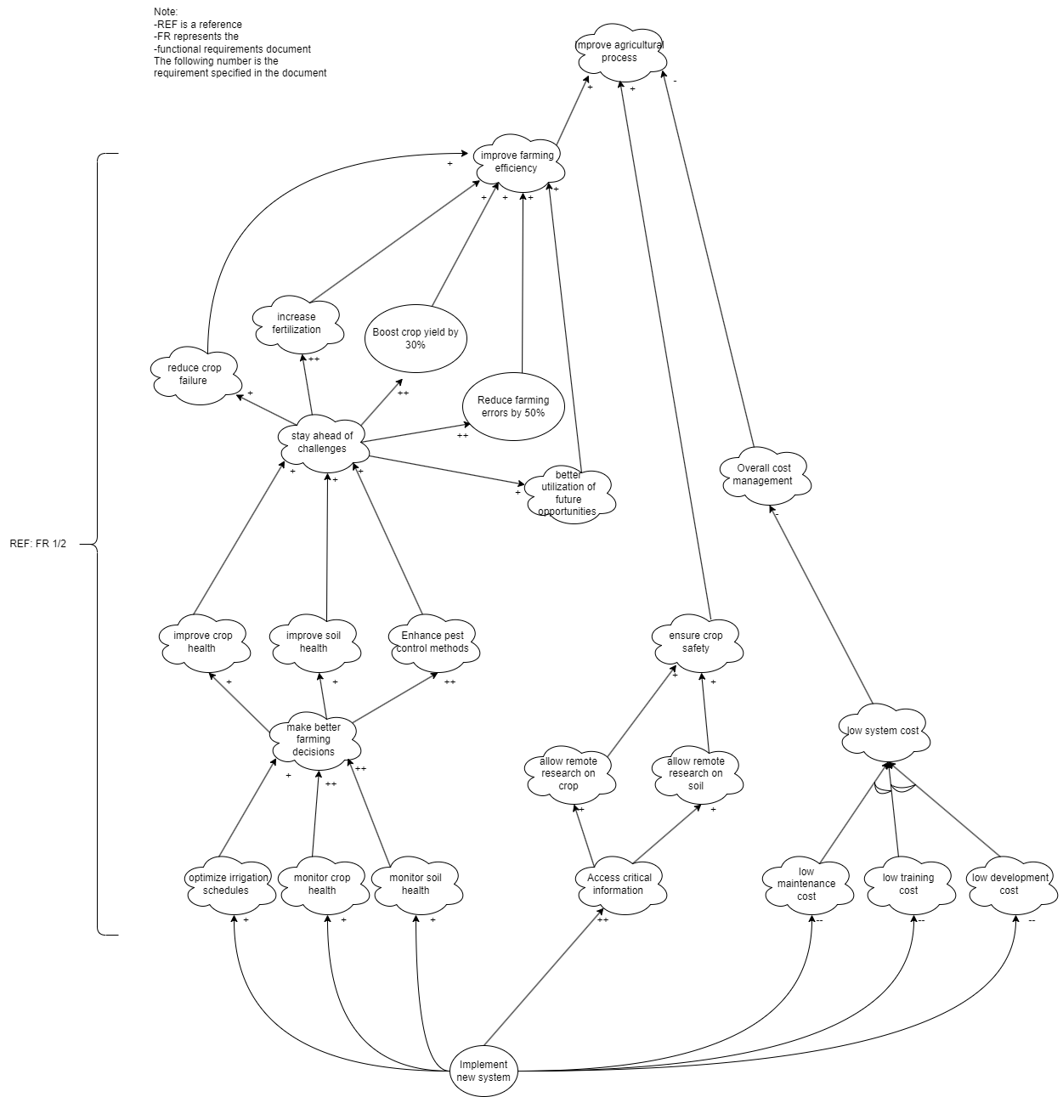
Figure 2: Goal Modeling to represent and analyze the goals and objectives of the system. This figure represents the system being implemented.
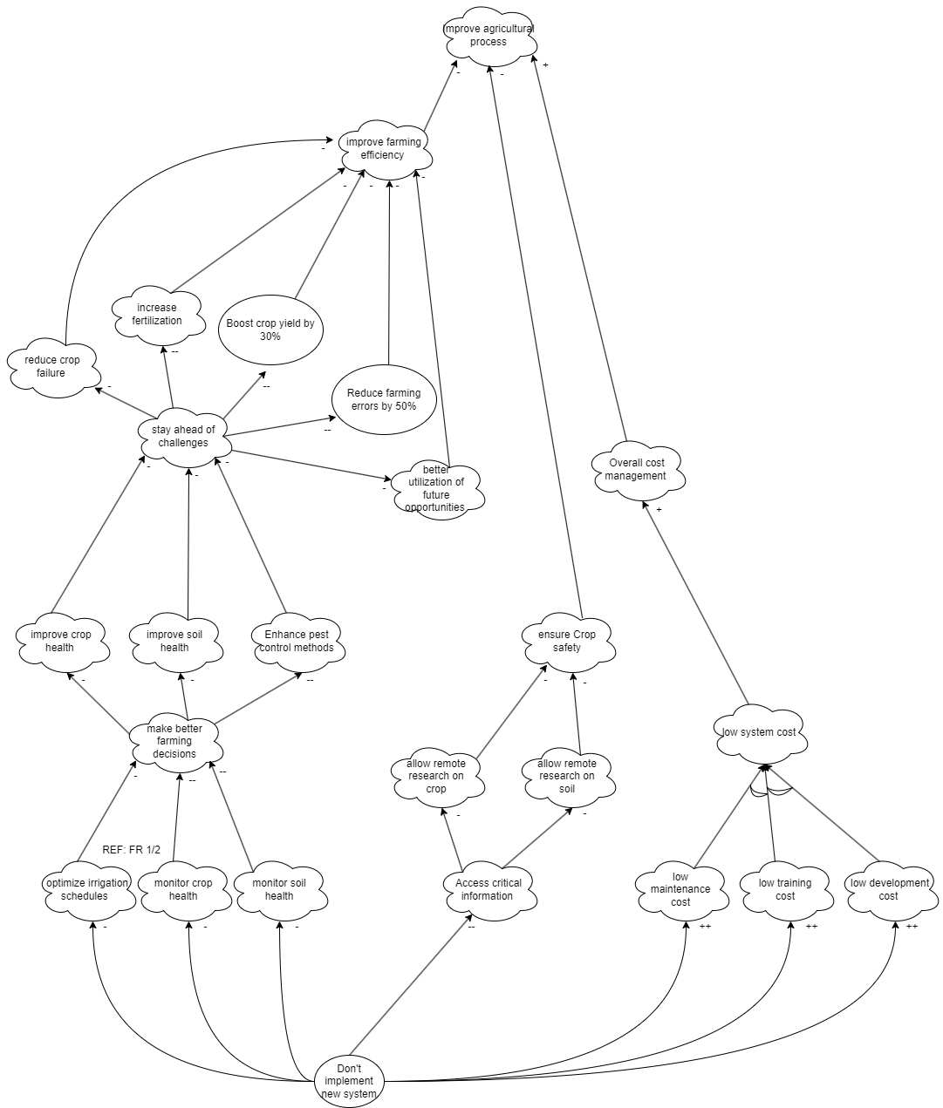
Figure 3: Goal Modeling to represent and analyze the goal and objectives of the system. This figure represents the system not being implemented.

Appendix A.3: Strategic Dependency Model
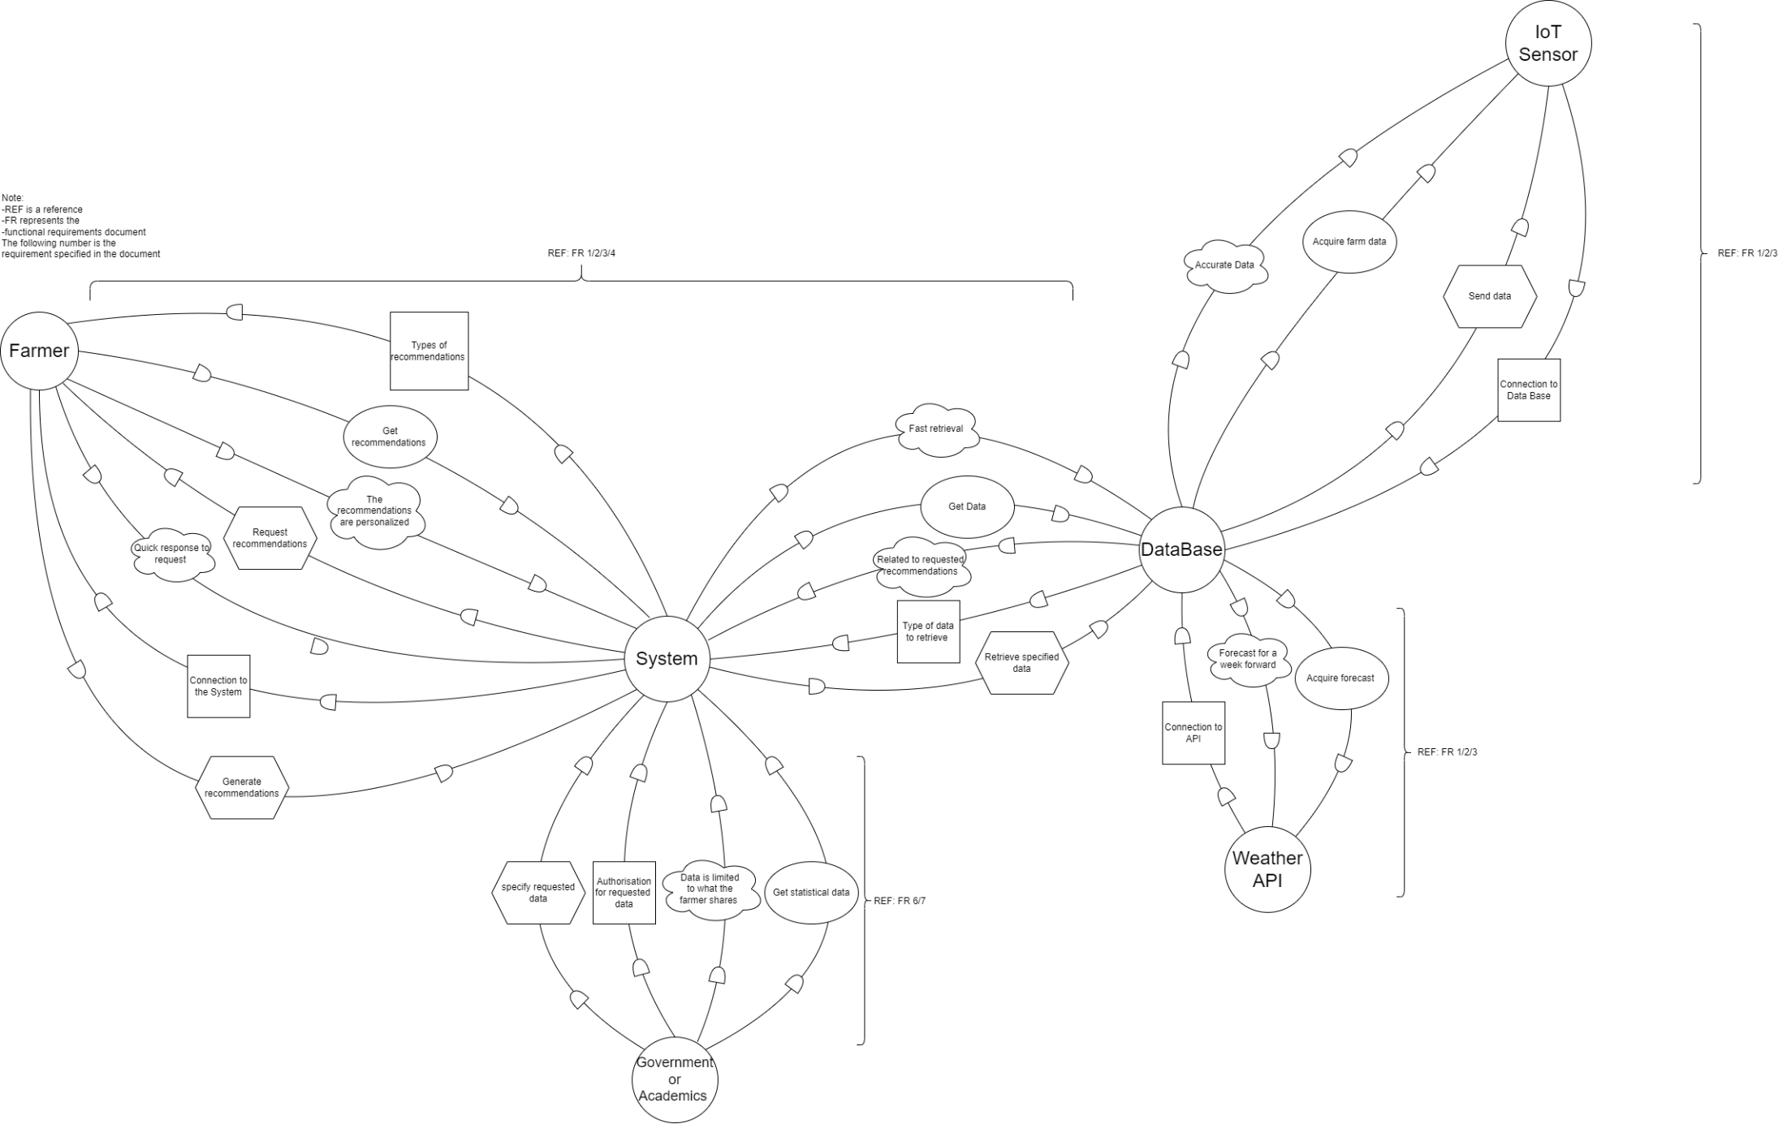
Figure 4: Strategic Dependency Model to represent the SD’s between actors, this helps understand how different actors influence each other.

Appendix A.4: Strategic Rationale Diagram
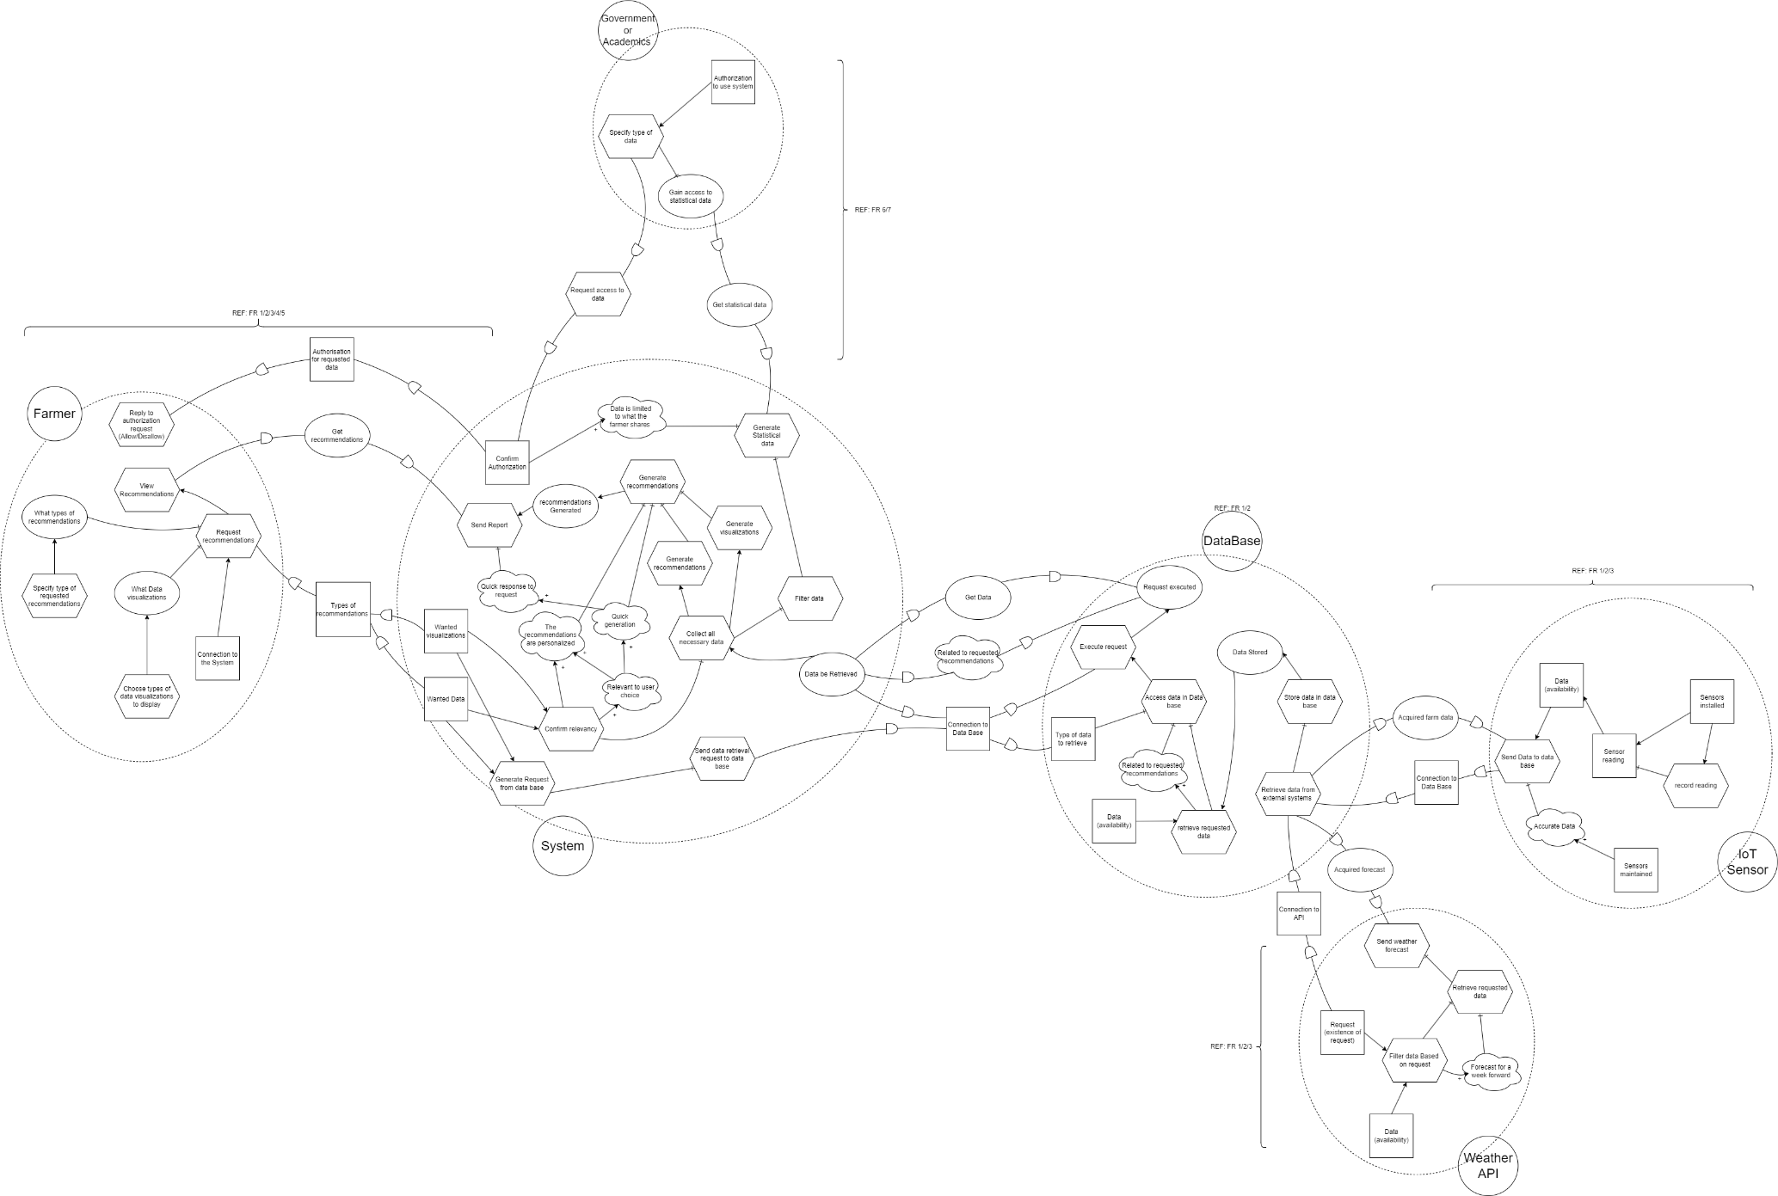
Figure 5: Strategic Rationale Diagram to complement the SD diagrams by providing a more detailed view of the influence each actor has on another.

Appendix B: Product Backlog and Burn Down/Burn Up Charts

Appendix B.1: Product Backlog
Table 1: Product Backlog for Functional Requirements.

Appendix B.2: Burn Down
Table 2: Velocity Calculations Table (for burn-down chart) according to product backlog, refer to Appendix E, Table 1.
Chart 1: Burn-Down Chart to show the work left to be done as time passes. This chart is done according to the Velocity Calculations Table, refer to Appendix B, Table 2.

Appendix B.3: Burn Up
Table 3: Velocity Calculations Table before scope change (for burn-up chart) according to product backlog, refer to Appendix E, Table 1.
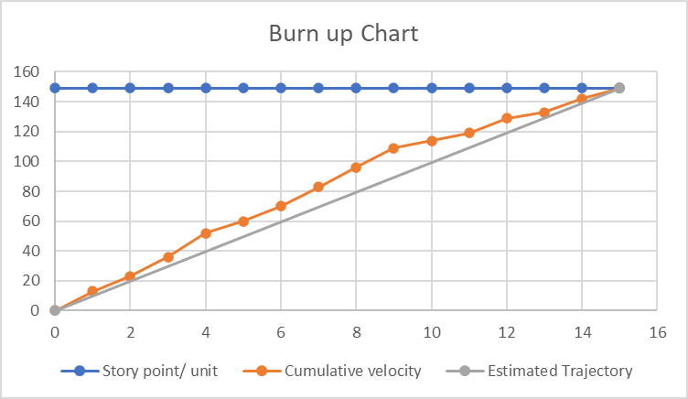
Chart 2: Burn-up Chart to track the progress of the project over time. This chart is done according to the Velocity Calculations Table before scope change, refer to Appendix G, Table 3.
This chart shows that throughout the 15 sprints assigned to the project, the actual progress was better than the expected progress, this meant that towards the final sprints the load was reduced as there was more time to work with.

Appendix B.4: Burn Up (Scope Change)
Table 4: Velocity Calculations Table after scope change (for burn-up chart).
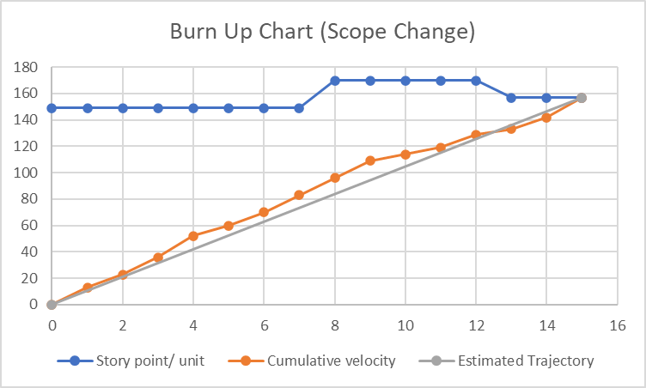
Chart 3: Burn-up Chart to track the progress of the project over time, this chart is done according to the Velocity Calculations Table after scope change, refer to Appendix H, Table 4.
This chart shows that, in the first few sprints the progress was according to the expected progress and better. But, towards the middle sprints, there was a significant scope change which led to a decline in the actual progress. Despite the scope change, the actual progress was still above the expected progress, this was the case until the final sprint where an increase to the load was necessary to complete the project in time.

Appendix C: System Requirements Specifications

Appendix D: Mockup Diagrams
